print("Sequence of number from 20 to 50:")

print(seq(20,50))

print("Mean number from 20 to 60:")

print(mean(20:60))

print("sum of numbers from 51 to 91")

print(sum(51:91))

output---

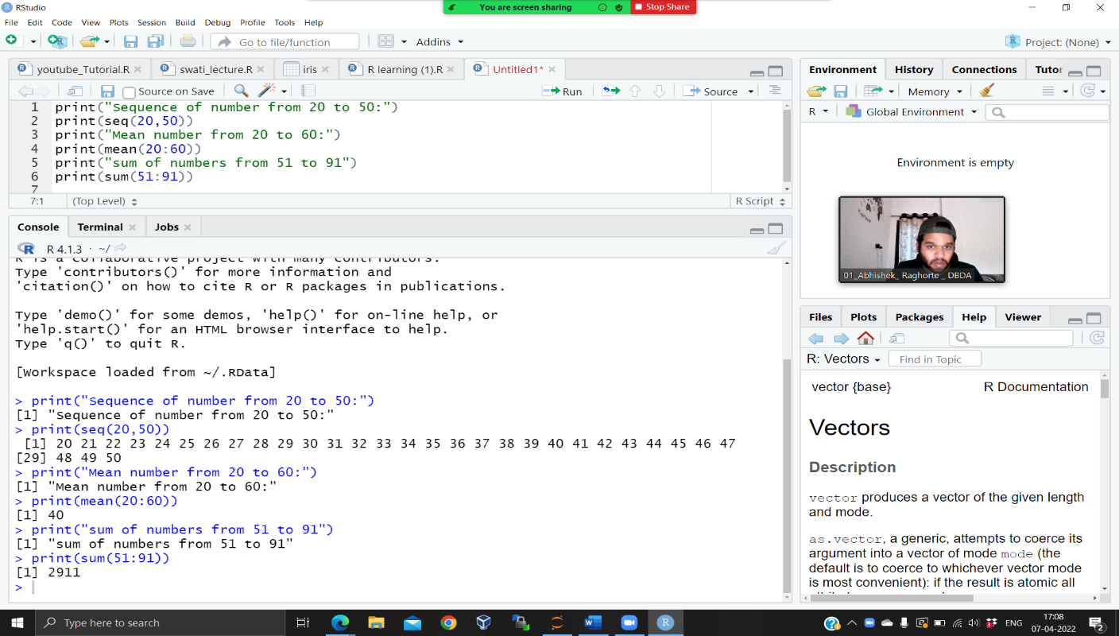

#2

for(n in 1:100) {

if (n%%3 == 0 & n %% 5 ==0) {print("FizzBuzz")}

else if (n %% 3 == 0) {print("Fizz")}

else if (n %% 5 == 0) {print("Buzz")}

else print(n)

